ADVANCED VISUALIZATION AND INTERACTIVE DASHBOARD DESIGN

Internship: YuvaIntern – Virtual Data Analysis Intern
Week: 5– Advanced visualization and interactive dashboard design
Dataset: UCI Online Retail Dataset
Student: Moksha
Project: E-Commerce Sales and Customer Analytics

1. ABSTRACT
This project focuses on developing an interactive dashboard for analyzing e-commerce sales transactions. The dashboard was developed as part of Week 5 of the YuvaIntern Virtual Data Analysis Internship. The main objective was to transform the results of previous data analysis tasks into an interactive and user-friendly visualization tool.
The dashboard was implemented using Python, Pandas, Streamlit, and Plotly. It provides important business metrics, including total revenue, quantity sold, unique invoices, and the number of countries represented in the filtered data. It also presents monthly revenue trends, the top 10 countries by revenue, the top 10 products by revenue, and the distribution of transaction-line revenue.
Interactive filters allow users to select countries and months to explore specific portions of the dataset. The dashboard also includes a transaction details table and a CSV download option for further analysis.
The completed dashboard demonstrates how interactive data visualization can help users understand sales performance, identify trends, compare markets, and support data-driven business decisions.

2. INTRODUCTION
E-commerce businesses generate large amounts of transaction data every day. This data contains useful information about products, quantities sold, prices, invoice details, dates, and customer locations. Analyzing this information helps businesses understand sales performance and identify opportunities for improvement.
However, examining large datasets using spreadsheets or raw CSV files can be time-consuming. Visualizations and interactive dashboards make the information easier to understand by presenting important metrics and trends in a clear format.
In the previous weeks of this internship project, data acquisition, cleaning, exploratory data analysis, visualization, and statistical modeling were performed. Week 5 builds on this work by converting the cleaned e-commerce dataset into an interactive dashboard.
The dashboard enables users to examine sales performance through charts, summary metrics, and filters without manually processing the dataset each time.

3. OBJECTIVES
The main objectives of this project are:
- To develop an interactive dashboard for e-commerce sales analysis.
- To present important business metrics using KPI cards.
- To visualize monthly revenue trends.
- To identify the top-performing countries and products by revenue.
- To understand the distribution of transaction-line revenue.
- To implement interactive country and month filters.
- To display transaction details in a structured table.
- To provide a CSV download option for filtered data.
- To design a dashboard that is simple, readable, and easy to use.
- To support data-driven decision-making through interactive visualizations.

4. DATASET DESCRIPTION
The dashboard uses the cleaned e-commerce transaction dataset prepared during the earlier weeks of the internship.
The dataset contains 524,878 transaction rows before the dashboard filters are applied. The data includes transaction information such as invoice number, invoice date, product description, quantity, unit price, and country.
The dashboard processes the data by converting the invoice date into a date-time format and converting quantity and unit price into numeric values. Records with missing required values are removed, and transactions with non-positive quantities or unit prices are excluded from the sales analysis.
A revenue column is calculated by multiplying quantity by unit price.
Revenue = Quantity × Unit Price
A month column is also created from the invoice date. These derived columns are used for monthly analysis and interactive filtering.
The dataset allows the dashboard to summarize sales performance across different months, products, and countries.

5. TOOLS AND TECHNOLOGIES USED

5.1 Python
Python is the primary programming language used to develop the dashboard. It is suitable for data processing, analysis, and application development because of its extensive collection of libraries.

5.2 Pandas
Pandas is used to load the CSV dataset, clean the data, convert data types, calculate revenue, group transactions, and prepare summarized data for visualizations.

5.3 Streamlit
Streamlit is a Python framework used to create the interactive web application. It provides the dashboard layout, sidebar filters, KPI cards, charts, data table, and download button.

5.4 Plotly
Plotly is used to create interactive charts. It supports visual exploration through features such as hovering over data points and examining chart values.
The project uses line charts, bar charts, and a histogram to present different aspects of sales performance.

5.5 Visual Studio Code
Visual Studio Code was used as the development environment to write and save the Python dashboard script.

5.6 CSV Dataset
The cleaned CSV file serves as the input data source for the dashboard. It allows the application to process the transaction records without modifying the original dataset.

6. DASHBOARD CONCEPTUALIZATION AND DESIGN
The dashboard was designed to present the most important information first and provide more detailed analysis below it.
The design follows a top-to-bottom layout.
Top section: The dashboard title and a short description introduce the project.
Sidebar: Country and month filters allow users to customize the displayed results.
KPI section: Four metric cards summarize revenue, quantity sold, unique invoices, and countries.
Visualization section: The monthly revenue trend appears first, followed by country and product comparisons and the revenue distribution chart.
Transaction section: A table displays selected transaction details, followed by an option to download the filtered data as a CSV file.
This structure helps users understand the overall sales performance before exploring individual trends and transaction records.

6.1 Layout Design Rationale
The dashboard uses a wide-page layout to provide more room for charts and summary metrics. Four KPI cards are arranged in a row, while the country and product charts are displayed in two columns.
The filters are placed in the sidebar to keep the main dashboard area organized. The transaction table is positioned toward the bottom because it provides detailed information rather than an overall summary.
The layout was selected to improve readability, reduce unnecessary scrolling between related visualizations, and make the dashboard easier to explore.
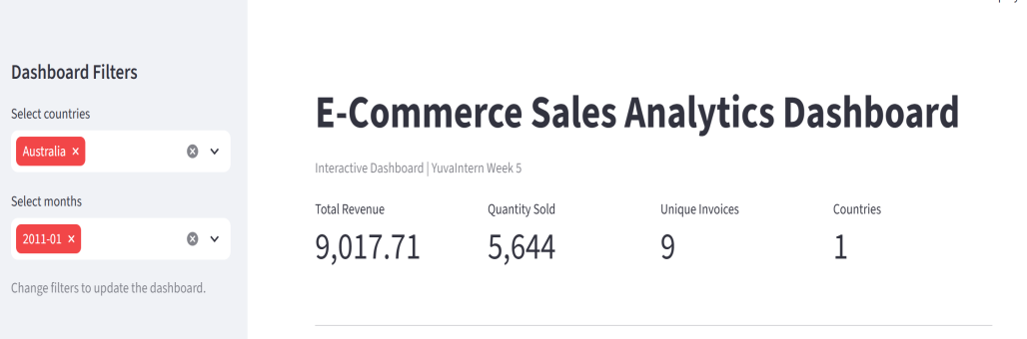
Fig 1: Main dashboard showing the title and key performance indicators.

7. KEY PERFORMANCE INDICATORS (KPIs)
The dashboard contains four KPI cards that summarize the selected transactions.

7.1 Total Revenue
Total revenue is calculated by multiplying the quantity of each transaction line by its unit price and summing the resulting values.
This metric provides an overview of the sales value represented by the selected data.

7.2 Quantity Sold
Quantity sold represents the sum of the quantities in the filtered transactions. It helps users understand the total number of units recorded in the sales data.

7.3 Unique Invoices
Unique invoices represent the number of distinct invoice numbers in the filtered dataset. This metric provides an indication of the volume of recorded transactions.

7.4 Number of Countries
This KPI shows the number of distinct countries represented in the filtered transactions. It helps users understand the geographic coverage of the selected sales data.
When all available countries and months are selected, the dashboard displays the following initial results:
- Total Revenue: 10,642,110.80
- Quantity Sold: 5,572,420
- Unique Invoices: 19,962
- Countries: 38
These values represent the dashboard's initial filtered view and may change when the user applies different filters.

8. INTERACTIVE DASHBOARD COMPONENTS

8.1 Country Filter
The country filter is implemented using a multiselect control in the sidebar. Users can select one or more countries to examine their sales performance.
When the selected countries change, the dashboard recalculates the KPI values and updates the charts and transaction table using the selected data.

8.2 Month Filter
The month filter allows users to select specific months from the available transaction dates.
This feature helps users focus on a particular period or compare sales performance across selected months.

8.3 Dynamic KPI Cards
The KPI cards update automatically according to the selected country and month filters. This makes it possible to compare different subsets of the dataset without manually recalculating the metrics.

8.4 Interactive Charts
The charts are created using Plotly and displayed through Streamlit. Users can hover over chart elements to inspect values and explore the visualized data.

8.5 Transaction Details Table
The transaction table displays selected fields such as invoice number, invoice date, product description, quantity, unit price, revenue, and country, depending on which columns are available in the dataset.
To keep the dashboard manageable, the table displays up to the first 100 rows of the filtered data.

8.6 CSV Download
The dashboard includes a download button that exports the displayed transaction columns from the filtered dataset as a CSV file.
This feature allows users to save the selected records and perform additional analysis using spreadsheet software or Python.
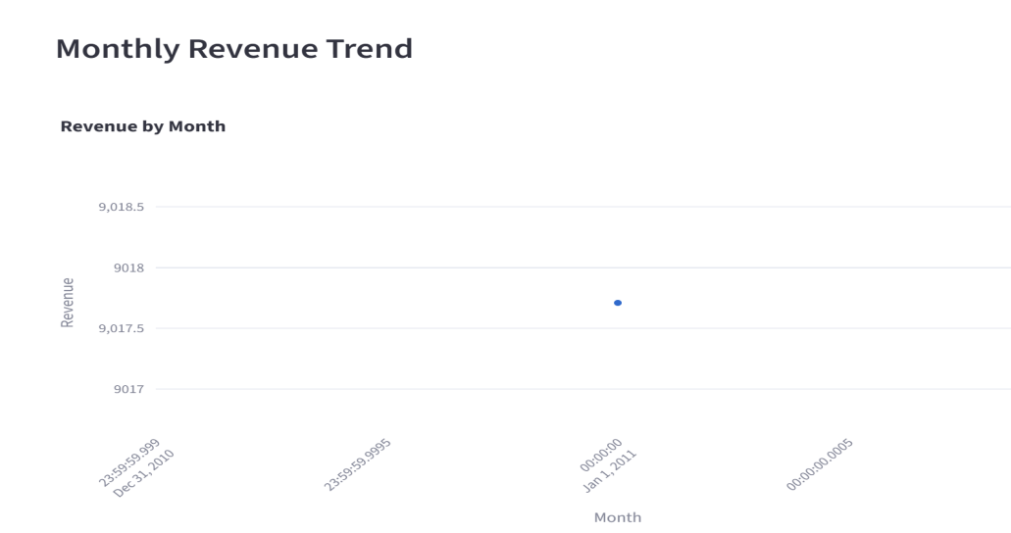
Fig 2: Interactive filters and monthly revenue visualization.

9. DATA VISUALIZATION AND ANALYSIS

9.1 Monthly Revenue Trend
A line chart is used to display revenue by month. The monthly revenue values are calculated by grouping transactions by month and summing their revenue.
The line chart helps users observe changes in sales performance over time. It can reveal periods with relatively high or low revenue and support further investigation of monthly patterns.

9.2 Top 10 Countries by Revenue
A horizontal bar chart displays the ten countries with the highest total revenue in the selected data.
The chart makes it easier to compare the revenue contribution of different countries. It can help identify major markets and areas that may require additional analysis.

9.3 Top 10 Products by Revenue
A horizontal bar chart presents the ten products with the highest total revenue.
Product descriptions are used when available. Otherwise, the dashboard uses stock codes to identify products.
This visualization helps users understand which products contribute most to the revenue in the selected transactions.

9.4 Revenue Distribution
A histogram displays the distribution of transaction-line revenue. It groups revenue values into intervals and shows how frequently values occur within those intervals.
This visualization can help identify common transaction-line revenue ranges and investigate whether a small number of transaction lines have unusually high values.
The histogram represents revenue per transaction line rather than total revenue per invoice.

9.5 Transaction Details
The transaction table provides access to individual records behind the summarized charts and KPIs. It allows users to inspect invoice details, product information, quantities, unit prices, calculated revenue, and countries.
Together, the visualizations provide an overview of sales performance and allow users to move from summary-level analysis to transaction-level inspection.
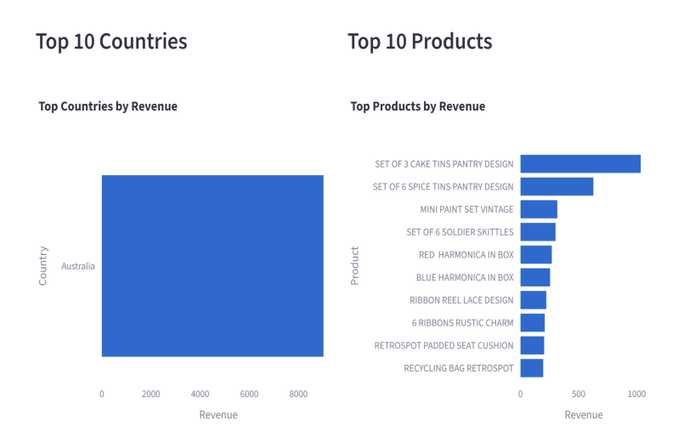
Fig 3: Comparison of countries and products based on revenue.
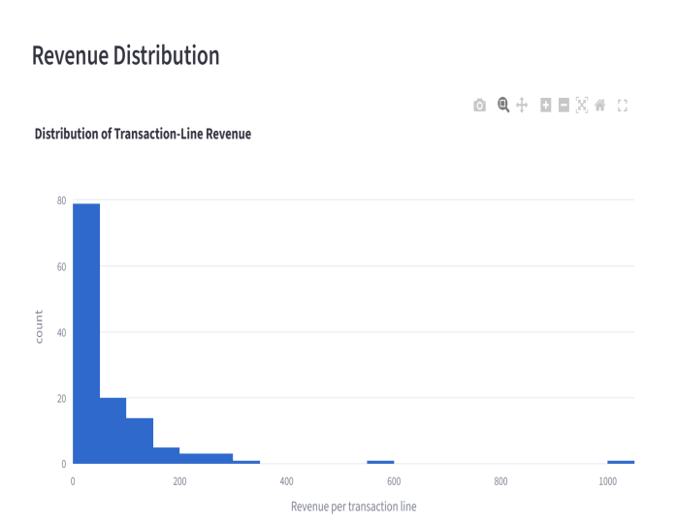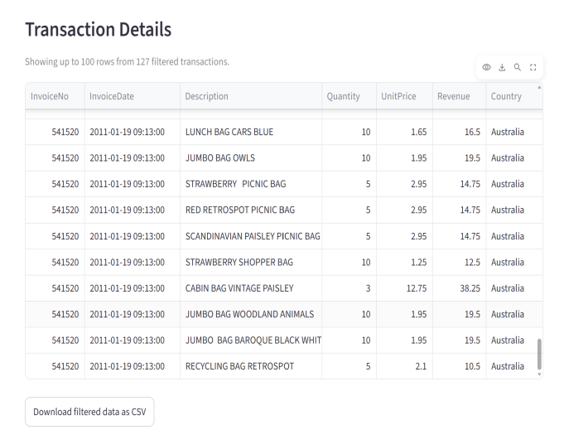
Fig 4: Revenue distribution and filtered transaction records.

10. IMPLEMENTATION AND WORKING LOGIC
The dashboard was implemented in a Python script named week5_dashboard.py.
The main implementation steps are described below.

Step 1: Import Libraries
The required libraries are imported:
- Streamlit for the dashboard interface.
- Pandas for data processing.
- Plotly Express for interactive charts.
- Pathlib for handling the dataset file path.

Step 2: Configure the Dashboard
The page title, page icon, and wide layout are configured using Streamlit's page configuration function.
A dashboard title and caption are displayed at the top of the application.

Step 3: Load the Dataset
The cleaned CSV file is loaded using Pandas. A caching decorator is used to avoid repeatedly loading the dataset during normal Streamlit reruns when the cached data remains valid.

Step 4: Clean and Prepare the Data
The invoice date is converted to a date-time format, while quantity and unit price are converted to numeric values.
Rows missing required values are removed. Transactions with non-positive quantities or unit prices are excluded from this sales dashboard.

Step 5: Create Derived Columns
Revenue is calculated by multiplying quantity by unit price. A month column is created from the invoice date to support monthly grouping and filtering.

Step 6: Create Interactive Filters
Multiselect controls are added to the sidebar for countries and months. The selected values are used to filter the dataset.

Step 7: Calculate KPI Values
The dashboard calculates total revenue, total quantity sold, unique invoice count, and the number of distinct countries from the filtered records.

Step 8: Generate Visualizations
The filtered data is grouped to calculate monthly revenue, revenue by country, and revenue by product. Plotly Express is used to generate the line chart, horizontal bar charts, and revenue histogram.

Step 9: Display Transaction Records
A transaction table is displayed using the selected columns. The table shows up to 100 rows to keep the visible output manageable.

Step 10: Add the Download Feature
A CSV file is generated from the filtered transaction data. Streamlit's download button allows users to download the selected records.

Step 11: Run the Application
The application is started from the project directory using the following command:
py -m streamlit run week5_dashboard.py
Streamlit launches the dashboard in a web browser, where the user can interact with the filters, charts, and transaction table.

11. RESPONSIVENESS AND USER EXPERIENCE
The dashboard uses Streamlit's wide layout to make effective use of the available screen space. KPI cards are arranged in columns, and the country and product charts are positioned side by side.
The charts use container-width settings so they can adapt to the available dashboard space. The sidebar separates filtering controls from the main visualizations.
The dashboard also provides feedback when the dataset is missing, no valid transactions are found, or the selected filters return no matching records.
These design decisions improve usability and help prevent confusion when users interact with the dashboard.

12. TESTING AND VALIDATION
The dashboard was tested to confirm that the main features worked as expected.
The following checks were performed or should be recorded based on the actual tests completed:
- Application launch: Confirmed that the dashboard opened successfully in the browser.
- Dataset loading: Confirmed that the cleaned transaction dataset was loaded.
- KPI display: Confirmed that the dashboard displayed revenue, quantity, invoice count, and country count.
- Chart display: Checked the monthly revenue trend, country comparison, product comparison, and revenue distribution visualizations.
- Country filter: Changed the selected country and checked whether the dashboard updated.
- Month filter: Changed the selected month and checked whether the displayed results updated.
- Transaction table: Checked the visible transaction details.
- CSV download: Tested the download button to confirm that filtered records could be exported.
The dashboard successfully loaded 524,878 transaction rows in its initial view and displayed the four KPI metrics. Additional filter and download tests should be marked as successful only after they have been performed.

13. USER JOURNEY AND DECISION SUPPORT
A typical user journey through the dashboard is described below.
First, the user opens the dashboard and reviews the KPI cards to understand the overall sales summary.
Next, the user selects a country or month from the sidebar to focus on a particular market or period.
The user then examines the monthly revenue trend to understand changes over time. The country and product charts can be used to compare revenue contributions and identify areas for further investigation.
After examining the visualizations, the user can inspect transaction-level information in the table and download the filtered data for additional analysis.
This workflow helps users move from an overall summary to more focused analysis. For example, a business analyst could use the dashboard to identify a high-revenue market, investigate the products contributing to its revenue, and examine the corresponding transaction records.
The dashboard supports decision-making by organizing sales information into an accessible format. However, it provides descriptive analysis rather than proving the causes of sales changes or predicting future sales.

14. CHALLENGES AND SOLUTIONS

14.1 Handling a Large Dataset
The dataset contains more than half a million transaction rows. Loading and processing a large dataset can require additional time and memory.
Solution: Pandas is used for data processing, and Streamlit caching is used to reduce repeated dataset loading during normal reruns.

14.2 Data Type Conversion
Date, quantity, and unit-price fields may not initially have the expected data types.
Solution: The dashboard explicitly converts these columns into appropriate formats and removes records with missing required values.

14.3 Interactive Filtering
Changing filter selections requires the dashboard metrics and charts to reflect the selected records consistently.
Solution: A single filtered DataFrame is used as the basis for the KPI calculations, charts, and transaction table.

14.4 Presenting Large Amounts of Information
Displaying all transaction records at once would make the dashboard difficult to navigate.
Solution: The transaction table displays up to 100 rows, while the download feature provides access to the full filtered selection.

15. HYPOTHETICAL USER FEEDBACK AND FUTURE IMPROVEMENTS
The following points are potential feedback and future enhancements, not feedback collected from actual users.
A user might appreciate the country and month filters because they allow sales information to be explored without modifying the source dataset. KPI cards and charts may also help users understand important results quickly.
Possible improvements include:
- Adding a date-range filter for more precise time-based analysis.
- Adding customer-level analysis if suitable customer identifiers are available.
- Adding a comparison of revenue and quantity across periods.
- Including additional metrics, such as average order value, with an appropriate invoice-level calculation.
- Improving performance through optimized data types or more efficient data processing.
- Adding automated data-quality checks.
- Providing more detailed product and country summaries.
- Deploying the dashboard online so authorized users can access it remotely.
- Improving accessibility through clearer labels and consistent formatting.
- Adding more advanced analytics in future versions.

16. PROJECT ARCHITECTURE
The dashboard follows a simple data-processing architecture.
Input Dataset → Data Loading → Data Cleaning → Feature Creation → Interactive Filtering → KPI Calculation and Visualization → Transaction Table and CSV Export
The cleaned CSV dataset serves as the input. Pandas performs data preparation and calculations. Streamlit manages the application interface and interactive controls. Plotly generates the charts displayed in the dashboard.
The country and month filters determine which transaction records are included in the dashboard's calculations. The resulting data is used to generate the KPIs, visualizations, transaction table, and downloadable CSV file.
This architecture separates the major tasks into clear stages and makes the application easier to understand and maintain.

17. LEARNING OUTCOMES
Through this project, I gained practical experience in:
- Building an interactive dashboard using Streamlit.
- Loading and processing a large CSV dataset using Pandas.
- Preparing date and numeric columns for analysis.
- Creating calculated fields for revenue and month.
- Developing interactive line charts, bar charts, and histograms using Plotly.
- Designing KPI cards to summarize business performance.
- Implementing interactive filters for country and month.
- Displaying transaction data in a table.
- Exporting filtered data to a CSV file.
- Testing dashboard components and organizing visual information for business analysis.
The project also helped me understand how the data cleaning and exploratory analysis performed in earlier weeks can be presented through an interactive application.

18. CONCLUSION
The Week 5 project successfully demonstrates the development of an interactive e-commerce sales analytics dashboard using Python, Pandas, Streamlit, and Plotly.
The dashboard presents four key performance indicators and provides visualizations for monthly revenue trends, top countries by revenue, top products by revenue, and transaction-line revenue distribution. Interactive country and month filters enable users to explore selected portions of the dataset. The transaction table and CSV download feature provide additional access to the underlying records.
The dashboard transforms a large transaction dataset into a more accessible and informative interface. It demonstrates the practical value of interactive visualization in exploring business data and supporting data-driven decisions.
This project completes the transition from data cleaning and exploratory analysis to an interactive dashboard, providing a foundation for future improvements in business intelligence and analytics.

